2 Days / 1 Night – Kulen Mountain Adventure & Camping
Names : TBA
No of pax : 15 pax (2group)
Organization : TBA
Date : 2023 - 2024
Consultant : Vanleat (Mr.)
Language: : English

EVENT/TRAVEL PLAN

Day 1/…/…./2023 Siem Reap – Kulen Mountain – Day One Adventuring

Day 2/…/…./2023 Day Two Adventuring – Return back to Siem Reap

Accommodation: Camping on Kulen Mountain

Important notice

Prepare your owned rainsuit jacket and waterproof gloves during motorbike trekking. Make sure to have owned charger and bottle of refilled water.

Date:
DAY 1 – SIEM REAP – Kulen Mountain - Day one Adventuring (-/L/d)

Get picked up from Siem Reap by A/C vehicle and transfer to Kulen mountain.

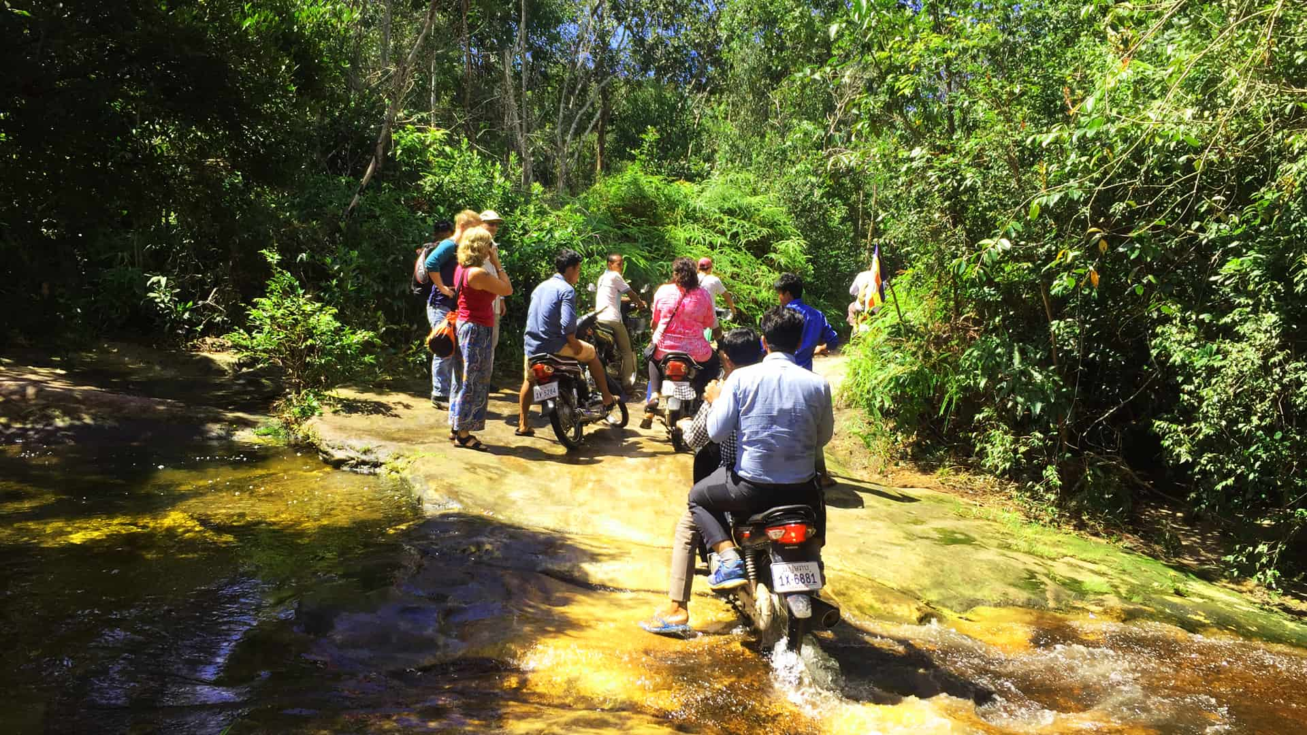
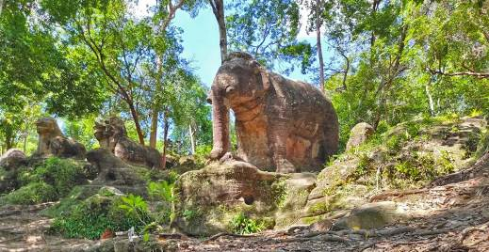
Arrived at the starting point where the local Motorcycle with drivers are waiting. Be a passenger and travel the jungle trails to visit the Poeng Bra-Jeav, Srash-Damrei Luch or picnic then continue to visit Kra-Bevkrap, Prasat O-tob, Poeng Ei-Sey and Ceramic kiln+ Prasat Neak-Ta if still have time.
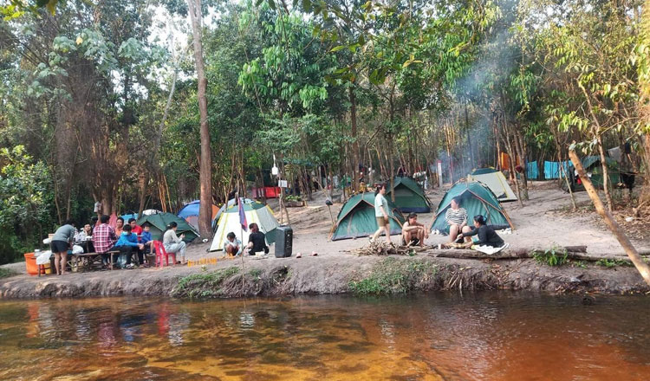

Travel back and onward to the Camp site at Peam Kre or at Prasat Kraham.

Overnight in the camp with BBQ dinner.

date:
DAY 2 – day two trek and relex by the waterfall – Siem reap (b/l/-)

Breakfast at the camp site.

Ride to sit at the Poeng-Tbal, Roung-Chen and O-Phaong temple them back to waterfall for lunch, then continue to see 1000Linga and few more around near water fall....
End of trip back to Siem Reap by AC vehicle.

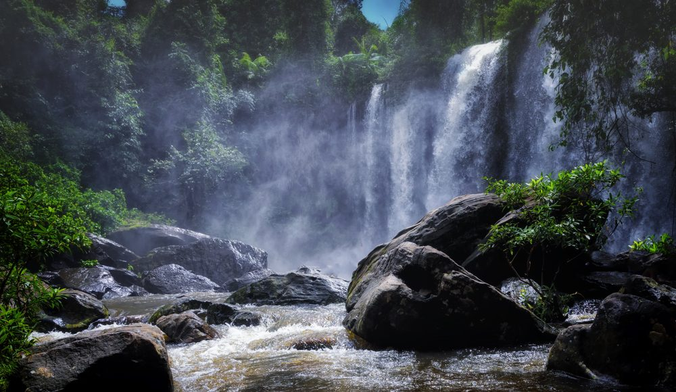

PRICE:
price per person – us. dollar | Group Range | Unit Price – Per person
2 Day Package Tours with English speaking guide | 15 pax | USD 157.00
2 Day Package Tours with English speaking guide | 2 pax | USD 280.00

SERVICES included:
- Local professional English-speaking guide during the mentioned destination
- Overnight camping at Kulen Mountain
- 1time breakfast, 2time lunch and 1time dinner include
- Tours and transfers as mentioned by private air-conditioned vehicle and motorbike at the mountain
- Entrance fees of Kulen Mountain

SERVICES NOT INCLUDED:
- Travel Insurance
- Cambodia visa fees (USD 40.00 NON-ASEAN) per person
- Expenditure of personal nature, such as drinks, laundry, souvenirs, tips…
- Other services more than mentioned in program
- International and domestic air-tickets & airport tax to/from Cambodia (see separate prices)
- Tipping to the local guide, driver, waiters and bellboy
- Surcharge for peak season noticed by the hotels

PAYMENTS CONDITIONS
- 50% deposit upon confirmation and full payment before the arrival date. (subject to discuss)
- We reserve the right to release all services in case of payment false.

CURRENCY:
The Riel is the local currency but the US Dollar is widely accepted and used in most transactions (4.100 Riel to 1 USD, April 2022). Credit cards, travellers cheques, foreign currencies are accepted in hotels and major banks. It is recommended to carry US Dollars in small denomination notes when shopping in the markets. Since the ANZ Royal Group introduced ATMs to Cambodia in 2005, the number of ATMs is constantly increasing across the country and nowadays you have access to cash 24/7 in Siem Reap, Phnom Penh, Battambang, Sihanoukville, Kampong Cham and even in some provincial capitals.

REMARKS:
- Itinerary is subject to change depending on the confirmed flights, road conditions, and rooms availability. We reserve the right to replace above hotels by other hotels of similar or superior category.
- We have not proceeded to any booking yet when sending the quotation.
- Airport taxes and fuel surcharge can increase without prior notice by governmental authorities. We reserve the right to apply the increase with immediate effect starting from the date of increase.
- Flights details and schedules mentioned in the program might be modified.

BOOKING PROCEDURE
- SAM INSPIRE CAMBODIA requires at least 50% advanced deposit to hold the booking. This amount can be paid by wire transfer, other mode of payment please contact our consultants.
- Remainder of total cost can be paid at SAM INSPIRE CAMBODIA office in cash, credit card.
- Except for the cash payment, any levied charges for the telegraphic/electronic transfer or any applied surcharges for credit card banking (3.5%) should be covered by the clients.
- Following the full payment, final voucher of services and related documents will be forwarded by e-mail at a maximum of two weeks prior to guests’ home departure.

HOTEL CHECK IN- CHECK OUT TIME
Hotel Check in time: 14.00- Check out time is 12h00 noon.
Early check-in or late check-out time may be granted subject to availability and agreement by the participating hotels.

REFUNDS & PENALTIES
Deposits are non - refundable but will be valid for any other substitute booking of the same calendar year and must be notified to SAM INSPIRE CAMBODIA earlier than 30 days prior to client's original schedule. Within 30 days of departure, deposits then are automatically non-replaceable and forfeited. Cancellations are subject to the following penalties of the full tour price:
Tours & Tour Packages Reservations:
- 24h to arrival day: 100 % charge
- 8-2 days 80 % of the tour price
- 15-9 days 50 % of the tour price
- 29-16 days up 15 % of the tour price
- +30 days up: no charge
Any late amendments to a confirmed booking may be added a fee imposed by SAM INSPIRE CAMBODIA where applicable and subject to specific circumstance.

LIABILITY REMARKS
The tour price does not include travel insurance, passport and visa fees, non per-payable airline and departure taxes, excess baggage charges, gratuities, laundry, phone calls and other communication costs, drinks, meals not listed in the itinerary, and all items of a personal nature.
SAM INSPIRE CAMBODIA and the clients understand the Booking facts described herein have been read and accepted by the clients. SAM INSPIRE CAMBODIA accepts no responsibility for any accidents, damage, loss, injury, sickness, death, cancellation, delay, deviation, substitutions or other unforeseen event unless caused expressly by the negligence per willful act of its self and its employees. Every endeavor has been made by SAM INSPIRE CAMBODIA to ensure that all the services are accurate at the time of final payment and SAM INSPIRE CAMBODIA shall not be under any obligations or to be liable to any person for any loss or damage suffered as a result of any inaccuracy or miss-description contained herein; or which may arise as a result of any changes in or withdrawal of any price, detail or services appearing herein due to circumstances beyond its control which due to actions or failures of third party carriers, sub-contractors, government bodies, military or terrorist actions.

TRAVEL INSURANCE
Nobody should travel abroad without insurance package that covers emergency medical evacuation, hospital costs and repatriation. SAM INSPIRE CAMBODIA recommends strongly to the client and considers it prerequisite to confirm any booking of your travel. You may also wish to purchase a policy to cover trip delay, cancellation or lost and stolen belongings. Please ask your closest agent for an appropriate recommendation or review the insurance policies prior to your final payment.

